HONG KONG INSTITUTE OF VOCATIONAL EDUCATION
Analyze web page data using Power BI Desktop
Name:_______________________ Time Allowed: 90 min
Class:_______________________ Date:_____________________

Lesson Intended Learning Outcome:
On completion of this lab, students are expected to be able to:
- learn how to import data from a web page into a report and create visualizations that show the UEFA European Championship (Euro Cup) winners over the years.

As a long-time soccer fan, you want to report on the UEFA European Championship (Euro Cup) winners over the years. With Power BI Desktop, you can import this data from a web page into a report and create visualizations that show the data. In this tutorial, you learn how to use Power BI Desktop to:
- Connect to a web data source and navigate across its available tables,
- Shape and transform data in the Power Query Editor,
- Name a query and import it into a Power BI Desktop report, and
- Create and customize a map and a pie chart visualization.

Procedures

A. Connect to a web data source
You can get the UEFA winners data from the Results table on the UEFA European Football Championship Wikipedia page at
http://en.wikipedia.org/wiki/UEFA_European_Football_Championship.
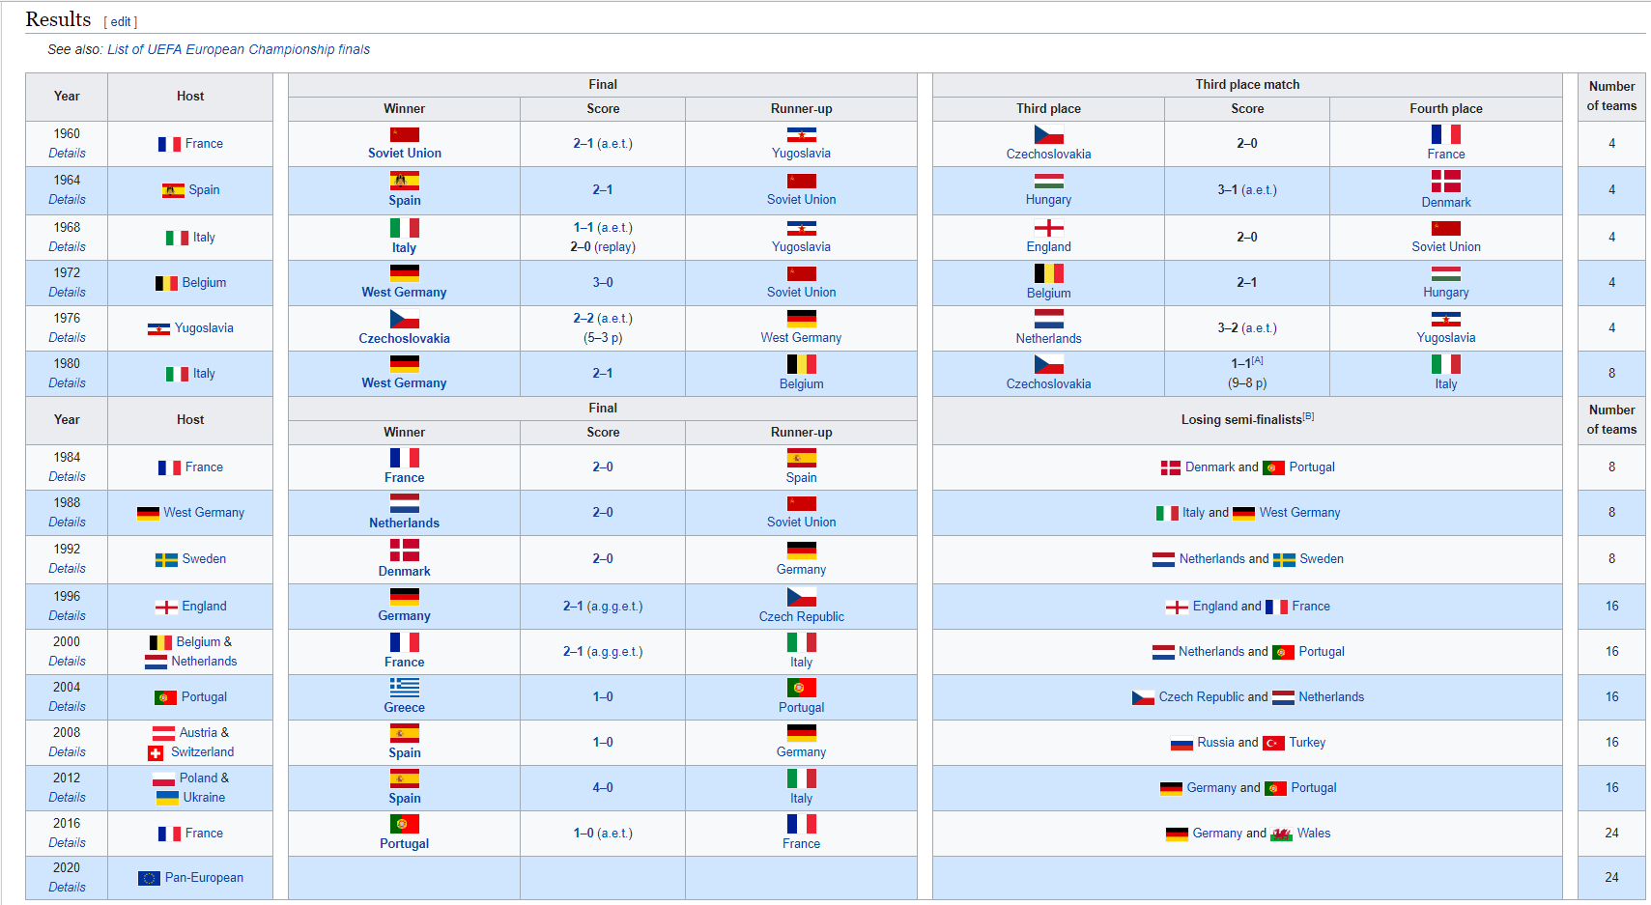
Note that Web connections are only established using basic authentication. Web sites requiring authentication may not work properly with the Web connector.

To import the data:
A1. In the Power BI Desktop Home ribbon tab, drop down the arrow next to Get Data, and then select Web.
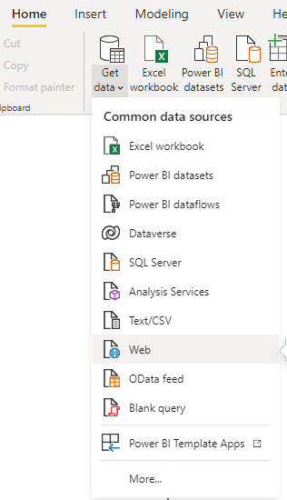
A2. In the From Web dialog box, paste the URL
http://en.wikipedia.org/wiki/UEFA_European_Football_Championship
into the URL text box, and then select OK.
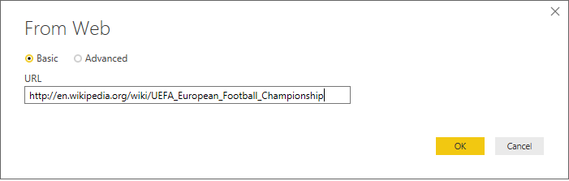
After connecting to the Wikipedia web page, the Power BI Navigator dialog box shows a list of available tables on the page. You can select any of the table names to preview its data. The Results[edit] table has the data you want, although it is not exactly in the shape you want. You will reshape and clean up the data before loading it into your report.
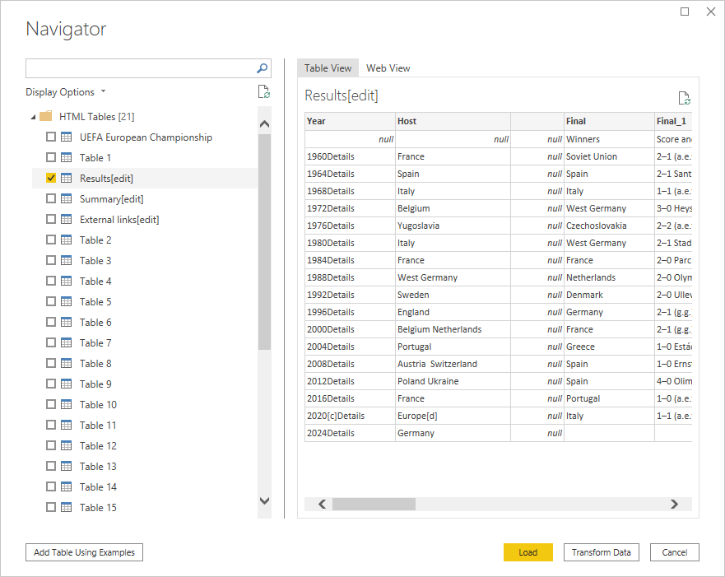
Note: The Preview pane shows the most recent table selected, but all selected tables will load into the Power Query Editor when you select Edit or Load.

A3. Select the Results[edit] table in the Navigator list, and then click Transform Data.
A preview of the table opens in the Power Query Editor, where you can apply transformations to clean up the data.
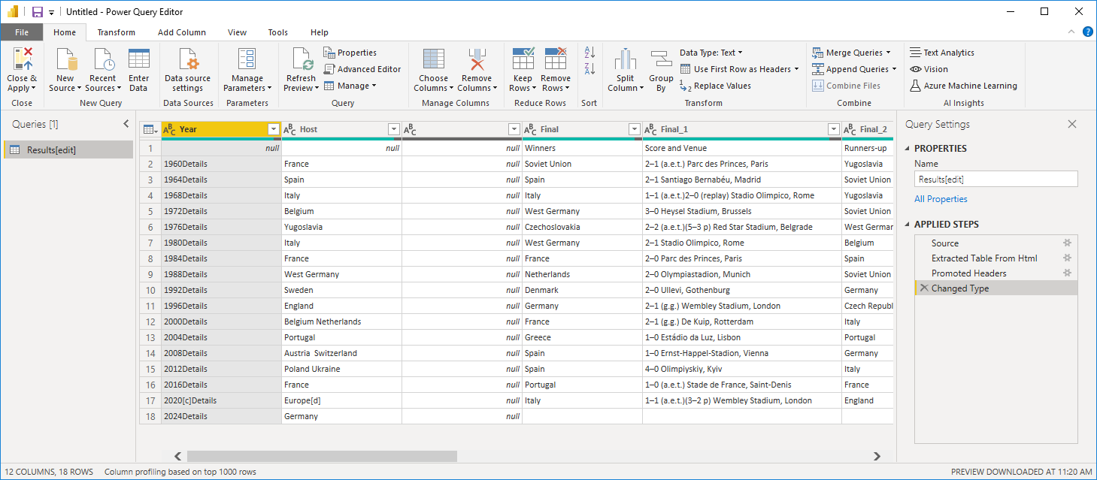

B. Shape data in Power Query Editor
You want to make the data easier to scan by displaying only the years and the countries that won. You can use the Power Query Editor to perform these data shaping and cleansing steps.
First, remove all the columns except Year and Final Winners from the table.

B1. In the Power Query Editor grid, select the Year and Final columns (hold down the Ctrl key to select multiple items).

B2. Right-click and select Remove Other Columns from the dropdown.
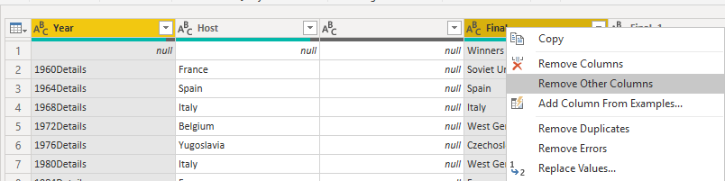
Next, remove the extra word “Details” from the Year column cells

B3. Select the Year column.

B4. Right-click, and select Replace Values from the dropdown.
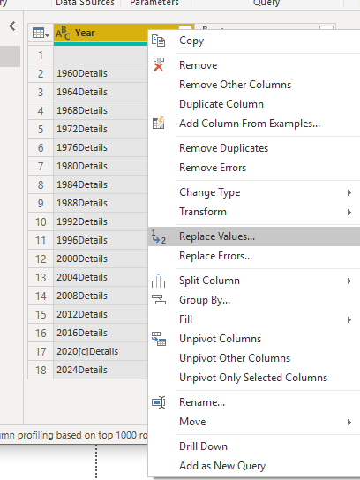

B5. In the Replace Values dialog box, type Details in the Value To Find text box, leave the Replace With text box empty, and then select OK to delete the word "Details" from the Year entries.
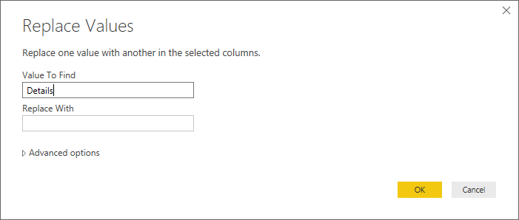

Some Year cells only contain the word "null" rather than year values. You can filter them out.

B6. Select the filter drop-down arrow on the Year column.

B7. In the drop-down, uncheck the (null) option, and then select OK.
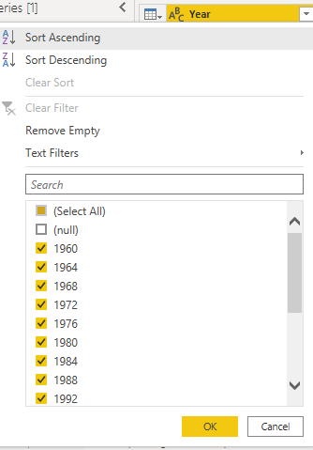
Now, you have cleaned up the data in the Year column, you can work on the Final column. Since you are only looking at the final winners data now, you can rename this column to Country. To rename the column:
B8. Double-click the Final column header

B9. Type Country in the header and press Enter to rename the column.

You may also want to filter out row Year 2024 that have no values in the Country column. You could use the filter menu as you did with the Year values.

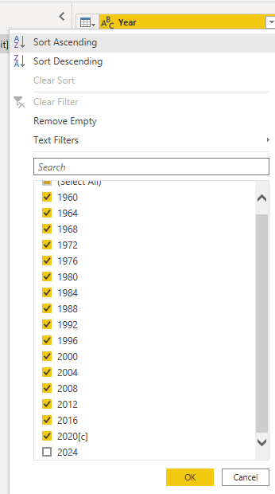

C. Import the query into Report View
Now that you've shaped the data the way you want, you're ready to name your query "Euro Cup Winners" and import it into your report.

C1. In the Query Settings pane, in the Name text box, type Euro Cup Winners, and then press Enter.
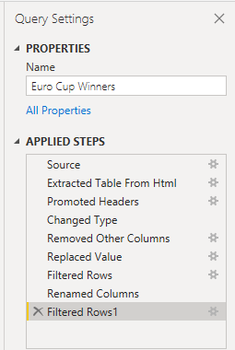

C2. Select Close & Apply > Close & Apply from the Home tab of the ribbon.
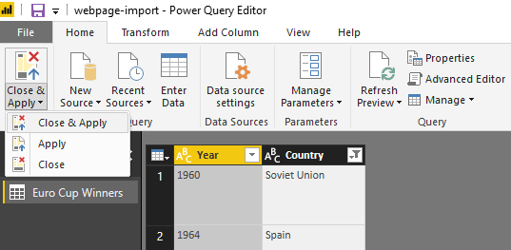
The query loads into the Power BI Desktop Report View, where you can see it in the Fields pane.

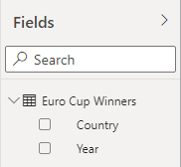
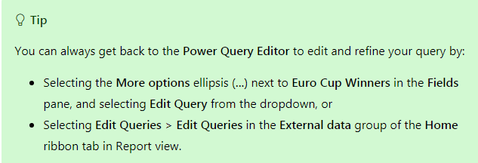

D. Create a visualization
To create a visualization based on your data:

D1. Select the Country field in the Fields pane, or drag it to the report canvas. Power BI Desktop recognizes the data as country names, and automatically creates a Map visualization.
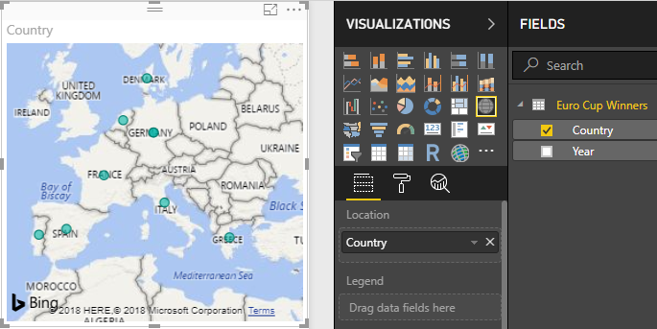

D2. Enlarge the map by dragging the handles in the corners so all the winning country names are visible.
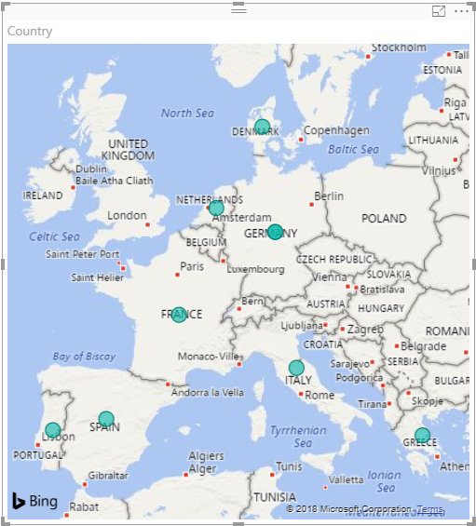
D3. The map shows identical data points (size) for every country that won a Euro Cup tournament. To make the size of each data point reflect how often the country has won, drag the Year field to Drag data fields here under Size in the lower part of the Visualizations pane. The field automatically changes to a Count of Year measure, and the map visualization now shows larger data points for countries that have won more tournaments.

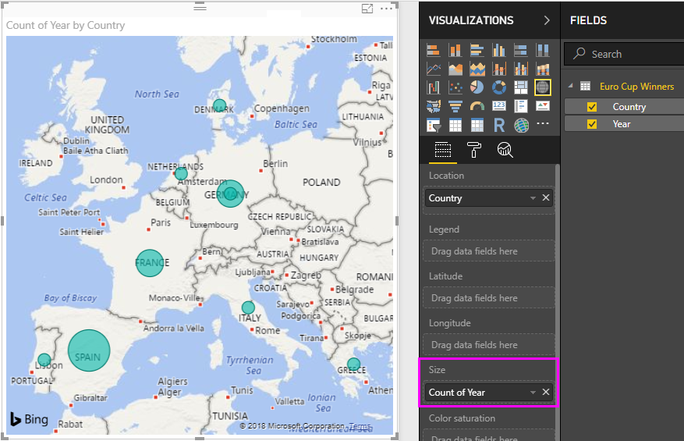

E. Customize the visualization
As you can see, it is very easy to create visualizations based on your data. It's also easy to customize your visualizations to better present the data in ways that you want.

Format the map
You can change the appearance of a visualization by selecting it and then selecting the Format (paint roller) icon in the Visualizations pane. For example, the "Germany" data point(s) in your visualization could be misleading, because West Germany won two tournaments and Germany won one, and the map superimposes the two points rather than separating or adding them together. You can color these two points differently to highlight this. You can also give the map a more descriptive and attractive title.

E1. With the visualization selected, select the Format icon, and then select Data colors to expand the data color options.
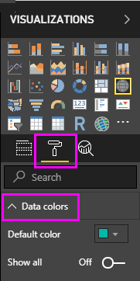

E2. Turn Show All to On, and then select the dropdown next to West Germany and choose a yellow color.
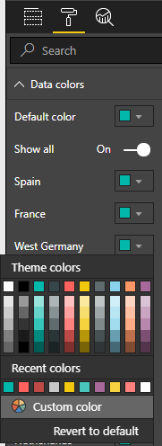

E3. Select Title to expand the title options, and in the Title text field, type Euro Cup Winners (your student name, student no.) in place of the current title.

E4. Change Font color to red, Text size to 12, and Font family to Segoe UI Bold.
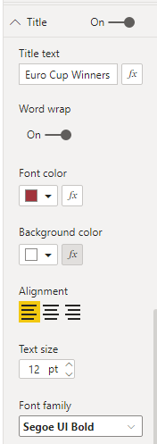
Your map visualization now looks like this:
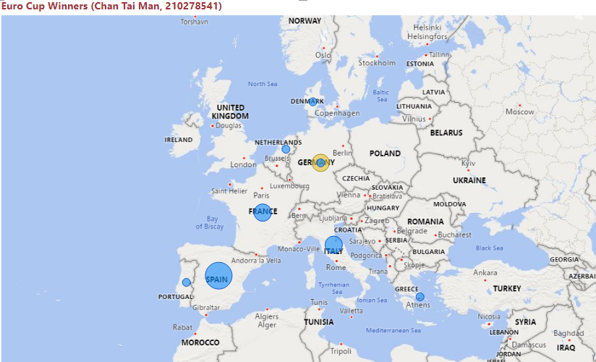

Capture and paste the whole screenshot below.

Change the visualization type
You can change the type of a visualization by selecting it and then selecting a different icon at the top of the Visualization pane. For example, your map visualization is missing the data for the Soviet Union and Czechoslovakia, because those countries no longer exist on the world map. Another type of visualization like a treemap or pie chart may be more accurate, because it shows all the values.
To change the map to a pie chart, select the map and then select the Pie chart icon in the Visualization pane.
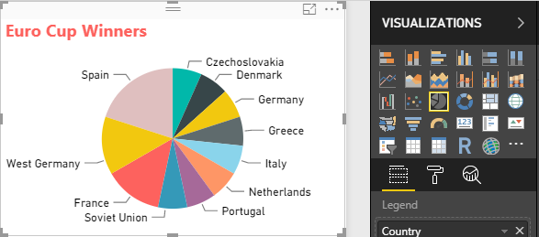

Power BI Desktop provides a seamless end-to-end experience, from getting data from a wide range of data sources and shaping it to meet your analysis needs, to visualizing this data in rich and interactive ways. Once your report is ready, you can upload it to Power BI and create dashboards based on it, which you can share with other Power BI users.

Submission of Exercise
Submit this exercise to Moodle after the lesson.
- END-

